
2023
1200 Brickell Ave.
Ste.1950 #1108
Miami FL. 33131
www.tailoredex.com
PH: 833-861-1610
Email: agents@tailoredex.com
TailoredEx Sales

Table of Contents
Market - 2 -
Small Business Overview - 2 -
What is a small business? - 2 -
Small Businesses by the Numbers - 2 -
Small Business Challenges - 5 -
Industries - 6 -
Business Finance Solutions - 6 -
Tailoredex - 7 -
TailoredEx Overview - 7 -
TailoredEx Mission - 7 -
How We Do What We Do - 7 -
Target Audience - 8 -
Agent's Job - 9 -
Expectations: - 9 -
Prices / Terms - 9 -
COMMISSIONS SPREAD – YOUR REVENUE POTENTIAL - 10 -
Types of Repayments - 10 -
Targeting - 11 -
How to acquire leads? - 11 -
Selling a Non-Bank Loan - 11 -
How to sell the product: - 12 -
Submitting an Application - 12 -
Fees - 12 -
Small Business Qualifications - 13 -
Sales Tips - 13 -
Cold Outreach - 13 -
Building a Network of Potential Lead Generators – Who to Target: - 13 -

Market

Small Business Overview

What is a small business?

The Small Business Administration (SBA) defines a small business as an enterprise having fewer than 500 employees (Depends on state and industry).

Small Businesses by the Numbers

- Small businesses are normally privately owned entities categorized as INC., LLC., and SP.
- In the U.S. there are approximately 33.2 million businesses that are qualified to be named a small business.
- About half of the working population (120 million people) are employed by Small Businesses.
- 8 out of 10 small businesses or 27.1 million are run by a single owner with no employees.
- In the U.S., an average of 425,729 businesses gets started each month.
- For most businesses, the biggest cost is labor. It makes up 70% of a business’s spending.
- Inventory is the second biggest cost for small businesses.
- Running out of capital is the second most common reason small businesses fail.
- Small Businesses account for 52.6% of all Retail sales.
- Small Businesses account for 46.8% of all Wholesale sales.

The bottom line is that most of us know someone who is involved somehow with small business. All small / medium businesses owners need right now, or will need soon working capital loan.
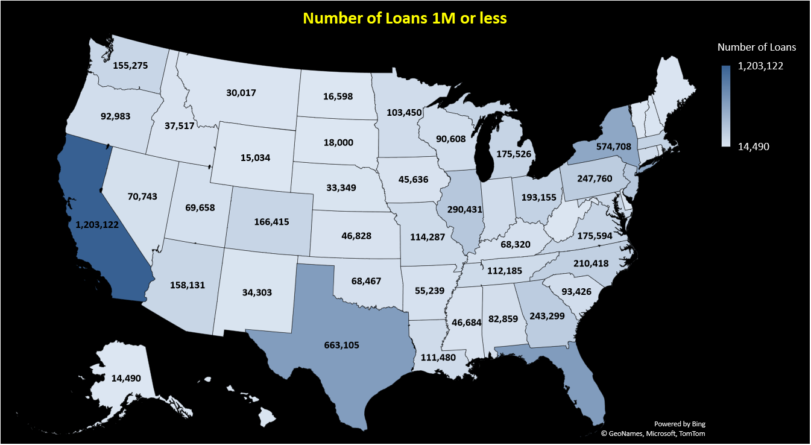
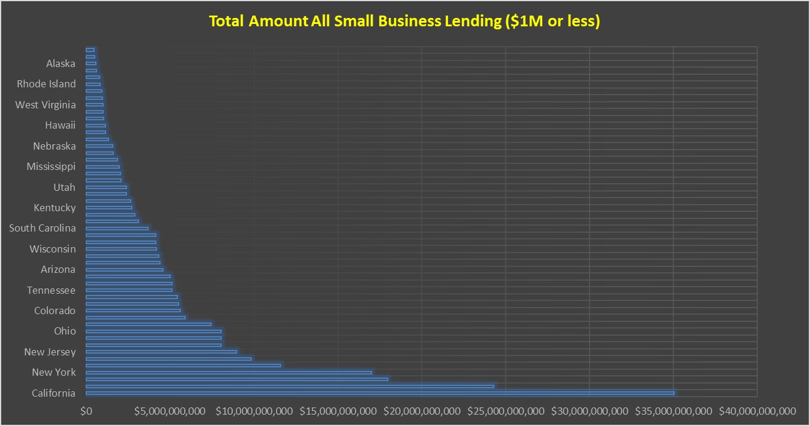
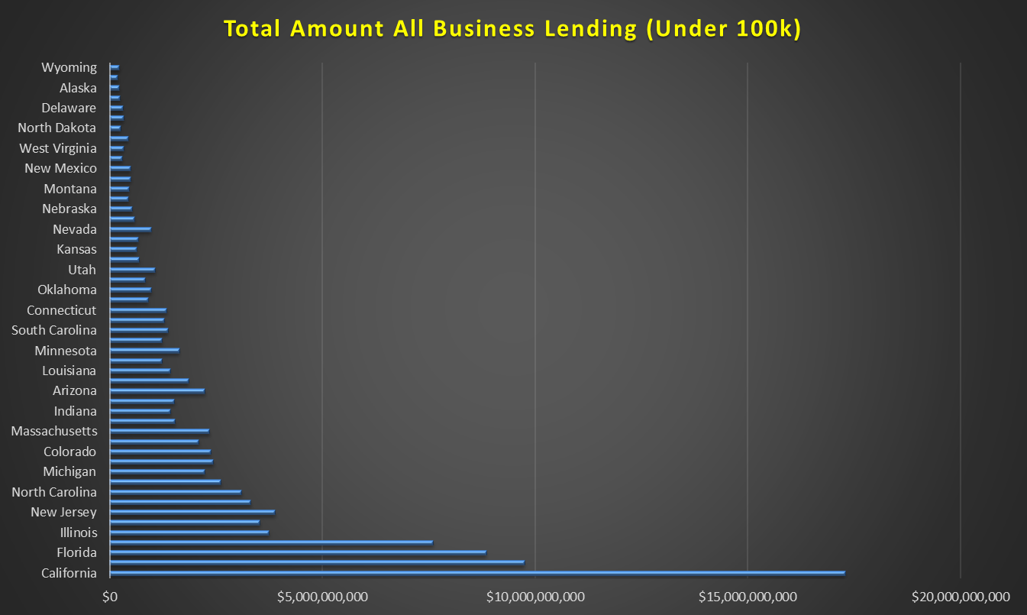

Small Business Challenges
Small Businesses often face problems related to their size - Bankruptcy is frequently caused due to undercapitalization, which is a result of poor planning rather than economic conditions.
A Small Business, at the startup level, should have access to a sum of money that is equal to the projected annual revenue for the first year in addition to his anticipated expenses.
Poor planning leads most Small Businesses to debt dependency after the first year of doing business and is one of the biggest reasons why a lot of businesses don’t last past the first year.
These are the most common concerns of Small Business owners:
- Unanticipated Expenses (Broken Machinery, Lawsuits)
- Opportunities (There’s merchandise for half the price and I need 100% of the money)
- Insurance Costs (Health & Liability)
- Rising Energy (Gas & Electric)
- Rise in Cost of Goods
- Taxes
- Rent Increase
- Marketing Costs
- Decrease in Sales (Seasonal Business)
- Accumulating Debt
- Human Resources (Quality, Learning Curves, An expert in a field won’t be an expert in running a business)
- Competition (Large corporations taking over big portions of the market and revenue)
- Small Business Regulations
- Access to Immediate Capital (Having a close relationship with a line of credit source)

Industries
You can find small businesses in many different industries ranging from your local deli to the factory that makes the clothes you find in any department store.
The fastest growing sectors within Small Businesses include:
- Auto Repair Shops | - Dry Cleaners | - Convenience Stores
- Bakeries | - Delis | - Hair Salons
- Tradesmen | - Restaurants | - Ad Companies
- Medical Institutions | - Bars | - Lodging
- Retailers | - Whole sellers | - Manufacturers
- Importers / Exporters | - Ecommerce | - Transportation
- Daycare | - Manufacturers | - and the list goes on....

Business Finance Solutions
- 60% of Small Business owners say that getting access to working capital is extremely challenging.
- 78% of Small Business owners say that expansions, inventory, and equipment purchases are the biggest triggers for seeking access to funding.

The avenues that can provide needed capital:
- SBA Loans | - Invoice Financing | - Real-Estate Loans
- Cash Advances | - Equipment Loans | - Investors
- Crowdfunding | - Hard Money Loans | - Bank Loans
- Bridge Loans | - Factoring Loans | - Friends & Family
- Non-Bank Loans | - Credit Cards | - Stocks Loans
- PO Factoring | - Equity Loans | - Fix and Flip Loans
- Cryptocurrency Loans | - Rehab Financing | - Personal Loans

TailoredEx does it all. We match a working capital program to any business that needs it in accordance with its unique needs.

Tailoredex

TailoredEx Overview
The idea behind TailoreEx is an offering of tailored expertise to business owners.
The TailoredEx’s team has more than 15 years of experience financing small/medium businesses across the U.S. Having worked on both sides; as direct lender executives we underwrote, analyzed, approved, and financed north of 100M in cumulative deals, and as a startup company with tentacles spread across the finance world we’ve experienced the hurdles small business owners face. With our connections, acquiring funds for existing businesses or even seed stage startups is made easy.

TailoredEx Mission
- We look at agents as partners and clients as friends.
- We believe that knowing our clients in person is good for business and beneficial for both sides. We thrive on personal relationships.
- We are here to help businesses grow.
- Any amount to be funded, we make sure the funds will help the business cash flow rather than just swamp and drown it in debt it cannot afford.

How We Do What We Do
After receiving a signed application and supporting 3 months bank statements, we determine which loan program is best for the prospect’s needs and apply it to our group of trusted lenders.
If one of the lenders approves an amount and wishes to continue with the funding, they will request more documentation such as:
- Business License
- Proof of identity – Driver License, ID, Passport, etc.
- Lease agreement for the business location.
- For high amounts a personal financial statement will be required.
After the approval, we come back to the client with an offer, typically, in less than 48 hours for $10K – 500K loans, and after both sides agree on the terms and sign the contract, monies are disbursed within 24 hours.
We try to tailor the best deal to suit the owner, with consideration of the business daily operation costs, at the lowest rate possible. That is why sometimes the offer we give is less than what the business owner had asked.
We need to be very careful with the amount of money we get; sometimes business owners, out of stress, or carelessness, ask for more than they can chew without paying attention to what that extra expense will do to their business. This is where TailoredEx’s professionalism shines.
Most applicants (90% of approved requests) will have the money in their bank accounts within 72 hours of the initial application.

Target Audience
- TailoredEx seeks and works with businesses that have been open for at least three months.
- TailoredEx funds businesses anywhere in the US.
- TailoredEx targets and deals only with business owners.
- TailoredEx works with all industries and is always open to consider new ventures.
- TailoredEx has funding solutions from $10,000 to $45,000,000.

Agent's Job

At TailoredEx we believe that an easy, personal and mutually-beneficial relationship with our partners and affiliates is necessary for success. We assist our agent partners by creating attractive and flexible funding packages that they can offer to potential clients.
We have access to an abundance of business databases and leads. We can supply you enough phone numbers and email addresses that will last for the rest of your life.
As a Referral Agent you need to know your prospective client’s needs.
Be passionate and believe in the product. Passion does take you places.
A good Agent has the ability to convert his expertise into understandable dialog, instead of using terms and jargon that might confuse the potential client. Speak in their language.
Understanding the in-and-outs of the product is a must.
Listen to what the customer has to say. Try to understand what the customer is looking for. Sell a product he needs, rather than relaying a sales pitch of a product that you want to sell.

Expectations:
The main goal for you is to refer potential clients in need of capital.
TailoredEx has access to a wide variety of business loans from $10K to $45M.
Set Appointments. You will be responsible for obtaining your own sales leads and for setting appointments based on those leads. The responsibility of setting appointments, staying in contact with the customer and showing up to appointments on time is yours alone.
Close the Deal. To you, closing the deal means having the client sign the funding application and retrieve the necessary documents; otherwise, the deal is not made and once you step out of the business the owner may have already changed his/her mind. You must be proficient in filling out the Funding Application and obtaining the proper signatures and documents.

Prices / Terms
- Pricing: rates range from 6% on SBA loans to 50% on cash advances.
- Terms: range from 3 months on cash advances to 15 years on SBA loans.
- Administration Fees: Monthly fees will be waived automatically. Wire fee only when wiring money from bank to bank. Returned Check or Ach fee will be charged whenever a payment bounces.

COMMISSIONS SPREAD – YOUR REVENUE POTENTIAL
We start as 60/40 partners on each deal you bring. You deliver to us the client with full agent packet. We close the deal. Bring more than 5 clients and we become 50/50 partners.
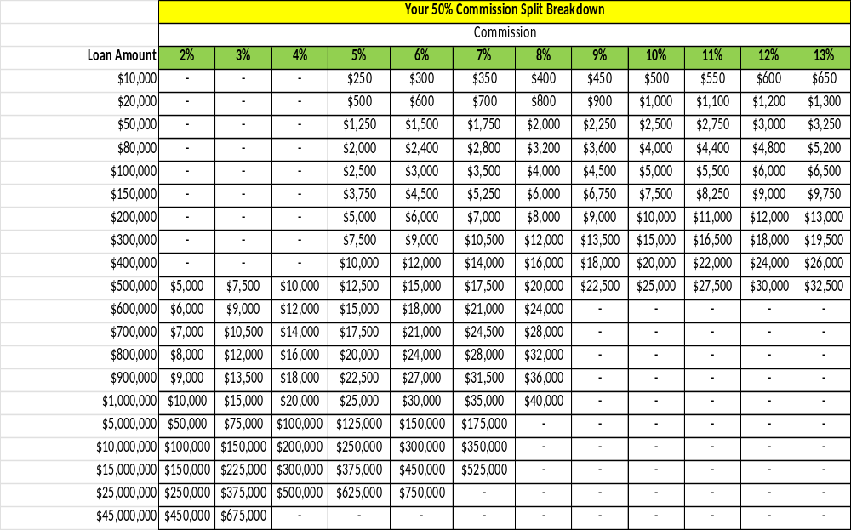

Types of Repayments
Daily or Weekly Ach (Automated Clearing House) – Lender will charge the borrower’s bank account either on daily or weekly basis.
CC Split – Lender will get a specified percentage of every credit card terminal batch settlement for repayment of the Loan and will continue until the loan is paid in full. Directly linked to the sales volume of the Credit Card sales only.
Invoice Factoring – Lender will get payments directly from your invoice supplier once they are paid.
Purchase Order – Lender will get payments once purchase order transforms into an invoice and is paid.
SBA Loan – Lender will debit the bank account monthly.

Targeting
Be assertive. Be innovative. Be Brash (leave an impression to make them remember you): Approach business owners anywhere you go. Introduce yourself to as many people as you can. Create a network of people that know you and your product. Hand out business cards. Advertise what you do on social media, and other than the traditional way think outside the box and find new ways to generate leads.
Target business owners! Don’t waste time talking to their managers.

How to acquire leads?
Regardless of what you do for a living there is always time. Business owners are everywhere; you probably know a few already, whether in your personal or professional life. Every conversation could ignite an opportunity.
- TailoredEx has access to a large database of business owners, phone numbers and emails. It’s your at no extra cost. Just make the calls.
- Social Media Networking: Use your social network (Facebook, YouTube, Linkedin, Instagram, and even Tik Tok etc.) to reach out to people and generate leads.
- Online Lead Generation: There are many online websites such as: Yelp, Google, Manta, Yellow Pages, and many more that offer databases or leads.
- Door-to-Door: The personal approach is probably the most efficient one. Communicating face to face when you are inside the business gives you a better understanding of the business, its owner, and better chances to close the deal. You are already there. Don’t leave before the owner signs.
- Telemarketing / Cold Calls: This form of letting people know about you is not yet dead. You work from home? Pick-up the phone on your spare time and call someone. Anyone. It costs you nothing and can get you some money just by talking. You drive the car all day? Prepare a list of names and call them from the road. It’s not illegal if you are using a hands-free device.
- Word of Mouth
- Paper/Online ads
- Acquaintances: Communicate what you do to as many people as you know.
Click on the link below to get access to a lot of agent resources, tips, and helpful information to better help you achieve your goals, at no cost, including business entity search links to all fifty states where you can extract a lot of information from their databases, mainly the owner’s name.

Agent Resources Page

Selling a Non-Bank Loan
Start by presenting the problems the business is facing and offer the solution. Be professional. Look professional. Know your product. Know how to present it. Use the keywords – “Fast, Personal, Simple.” Always be positive. Know and memorize the key selling points.

How to sell the product:
The keywords, phrases, and sentences to sell a business loan are divided into two categories.
The No’s and Yes’s.
The No’s:
- No! Personal Guaranty is not mandatory.
- No! There are no use restrictions.
- No! Collateral. Only some high value loans require collateral.
- No! There is no fixed payback schedule on some loans.
The Yes’s:
- Yes! You can use the money any way you choose.
- Yes! You will fill out much less paperwork than bank loans.
- Yes! The process of getting your money is quicker and far less onerous than a bank loan.
- Yes! You will have money in your hand in less than 72 hours. Depending on the loan.
- Yes! The application process is free of charge.
- Yes! All your questions and needs will be addressed by a professional.
- Yes! Our main goal is helping you grow your business.
- Yes! We will be there for you in the long term. We hope to be there for you when you pass the keys to your son.

Submitting an Application
The minimum requirements to submit an application:
- At least 3-6 months of the most recent business bank statements (more months might help reduce the risk and result in more money funded and better rates).
- Complete & signed funding application: must be signed by the owner to allow personal credit report (when needed) and to verify good standing with the landlord.
- Business License.

Fees
Charging processing fees is status quo! But we waive all fees at the time of signing to help them feel good. “We usually charge $200-$500 processing fees, but I’ll waive that for your this time.”

Industry Accepted Processing Fees
$0 - $5,000 = $95 $5,001 - $10,000 = $195 $10,001 - $20,000 = $295
$20,001 - $40,000 = $395 $40,001 - $80,000 = $495 $80,000 + = $595
Small Business Qualifications
- Startups – can qualify as long as they have collateralized asset.
- Any business with a sales history of at least 3 months.
- Minimum $20,000 gross monthly sales.
Sales Tips

Cold Outreach
Always remember you only have less than 10 seconds to make or break a first impression. That is why successful salespeople dress the part, look dapper, and speak eloquently. The tone of voice and choice of words are critical. Shake hands firmly, and make good eye contact. And always! Always answer a question with a question!
Here’s how to pitch our product when cold calling a business owner: Ring ring.
- Prospect: Hello!
- You: Is Mark! / Mary! / David! / Business owner name there? May I speak with the Owner?
- Prospect: Yes / Speaking / Mark isn’t here / Yes, who is this?
- You: Hey “Owner’s name,” my name is John Doe (State Full Name), I’m vp of sales at TailoredEx, we’re a financial solutions company, I know you must be getting dozens of calls offering you business loans with short terms and high rates. We’re doing the opposite, long terms with low rates, who is your go to for working capital?
- Prospect: What? / Who is this? / I don’t need it! / My wife takes care of it. / My bank.
- You: I just want to know, do you have someone you can trust to get you the funds you need when you need them?
- Prospect: Yes / No.
- You: I just wanted to introduce myself. My name is John Doe. I can get you access to loans from 10K – 45M, we make sure our clients get the best programs. We’re building relationships for the long run. Can I help you with anything today?
- Prospect: I don’t need it. Okay, but I don’t need it.
- You: I understand that you do not need it now, but here’s my number and my email, I’ll text you my email and phone number, so when you ever need any help with funds of any kind, you’ll know how to reach me. What’s your email / phone number?

Building a Network of Potential Lead Generators – Who to Target:
- Banker Friend or Family Member | - Insurance Agents
- Merchant Services ISOs (CC Salespeople) | - 401K Providers
- Payroll Services | - Website Developers
- Check Cashing Services | - HR Companies
- Accountants | - Temp Services
- Bookkeepers | - Real Estate Brokers
- Business Advisors / Consultants | - Independent Salespeople
- Lawyers | - Parcel Services
- Business Managers | - Church Pastors
- Delivery Drivers | - Doormen

